Securing Broadcast Communication
Trivial Broadcast Key
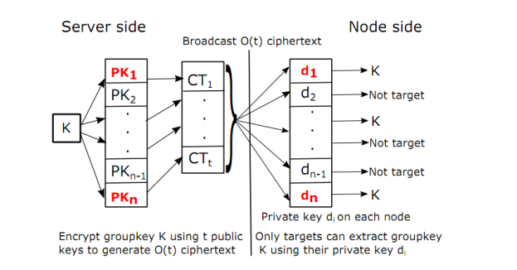
Hash chains
Take message M, hash M (i.e. H(M)), then hash H(M) (i.e. H(H(M)) ) and hash again and hash again many times over
Used for authentication: client sends second-last hash of k hashes (e.g. 1000) to server, server hashes 999th hash and compares with it’s 1000th hash to check if client had the same initial M → if 1000th hashes match, client can be authenticated
Code dissemination
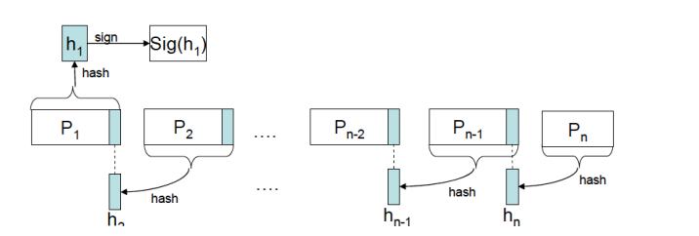
Allows AP to authenticate itself to clients
AP then broadcasts to clients, who can decrypt hash with AP’s public key and authenticate entire message by comparing it with the decrypted hash
Merkle Hash Tree
Takes each page and hashes them → these are the leaves
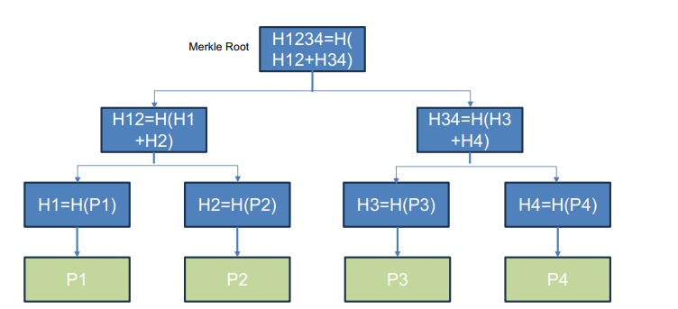
Takes two page hashes (e.g. H1, H2), concatenates them and then takes hash of concatenation (e.g. H12) → does recursively until obtains merkle root

If client only wants to verify that a single page exists in the data set, then it needs each twin node, not just merkle root
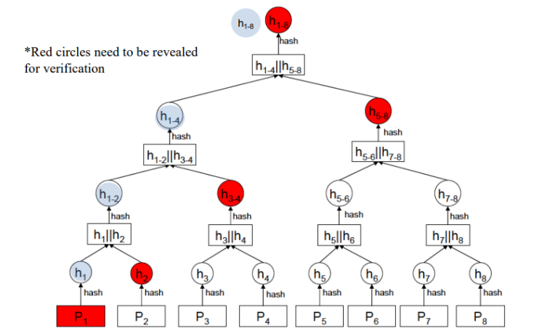

Distributed Energy Resources Case Study
The goal is to minimize the risk of cyberattacks on the distribution grid and maintain safety, reliability, and resiliency.
2. Key Requirements:
Resource Criticality Levels: DERs are categorized as high, medium, or low impact based on potential misuse risks to grid reliability, public safety, finances, and privacy.
Network Segmentation: Devices with different criticality levels must be isolated into separate security zones (e.g., high, medium, low impact zones). Communication between zones should be controlled through security gateways and routed through a Demilitarized Zone (DMZ) if interacting with external networks.
DMZ: is a buffer zone between external-facing services (DNS, mail and web servers) in an internal network and untrusted external network (e.g. internet). Consists of inner firewall, to separate internal network and DMZ and outer firewall, to separate DMZ and internet.
Boundary Protection: Security gateways between zones should block connections from lower to higher criticality zones by default.
High-impact and external-facing gateways require 24/7 monitoring.
Communication Integrity and Confidentiality: All DER communications must include authentication, message integrity, and alteration detection, using cryptographic methods like TLS, IPsec, or SSH.

Data must be encrypted end-to-end, particularly when crossing external networks or involving high-impact resources.
Communication Partitioning: High-impact DER communications should be physically or logically separated from other types of communication using dedicated networks or VLANs.
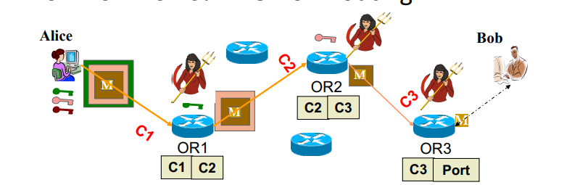
Network Service Protection: Only authorized devices are permitted to connect, using methods like MAC address filtering or WPA2.
MFA is required for network management, DNSSEC to prevent DNS spoofing, and ARP spoofing protection should be enabled.
Denial of Service (DoS) Protection: High-impact resources should not be publicly accessible.
Use camouflage, redundant communication paths, and DoS/DDoS mitigation services to minimize the attack surface.
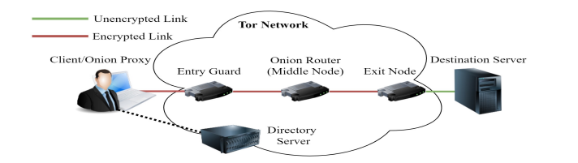
TOR

Tor Mechanisms
Client gets list of all active tor routers from directory server
Client picks 3 random tor routers for the following purposes: entry node, middle onion router (OR) and exit node
Client (e.g. Alice) establishes connection, C1, with entry node (OR1) and generates a symmetric key
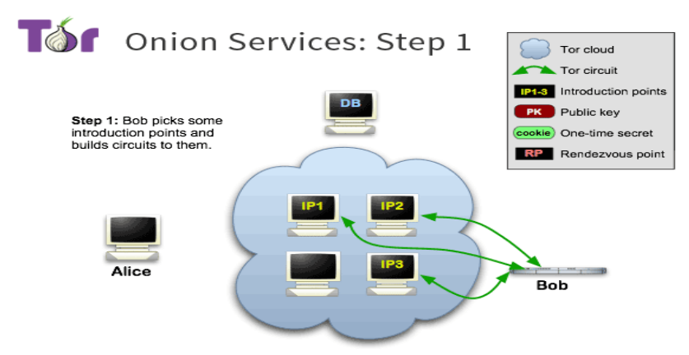
Entry node establishes connection C2 with next tor node (OR2) and allows alice to generate a separate symmetric key with OR2;
OR2 establishes connection C3 with exit node (OR3) and allows alice to generate a symmetric key with OR3
Each tor node maintains table of connections, allowing it to route a received packet to next router in alice’s Tor topology
When alice wants to send a message to bob using Tor network, first encrypts it with OR3’s symmetric key, then OR2’s key and finally OR1’s key → results in 3 layers of encryption (like onion)
Alice then sends encrypted message, E(M) to OR1; OR1 decrypts first layer, checks if it was the intended destination of the message and if not, forwards it to the next router according to forwarding table
OR2 repeats this process, removing a 2nd layer of encryption and forwarding E(M) to OR3, which removes final layer of TOR encryption and forwards to recipient Bob

Attacks on Tor
A malicious actor, Eve, at OR3 would be able to see the plaintext message when it is being sent to Bob, because M is no longer encrypted using shared keys (may still be encrypted using TLS)
If Eve is at OR1, she will have the symmetric key for the outermost layer of encryption and will also know that Alice is sender; won’t be able to decrypt message because its still encrypted with 2 more layers of encryption
If Eve is at OR2, she will have least amount of information- doesn’t know sender or receiver and message is also encrypted
If Eve is at both OR1 and OR3, then knows all information (snder, recipient and message)
Hidden service
Allows destination server (i.e. recipient) to also hide it’s IP so that it can’t be tracked
Server (e.g. Bob) sets up 3 tor circuits with 3 hosts, IP1, IP2 and IP3 in the Tor network
Each tor circuit is composed of another 3 nodes that relay the communication between IP* and Bob

